EIDLIMS Redevelopment Schedule:
The present EIDLIMS system, though functional, suffers several challenges especially with regard to data integrity and system functionality. To address these and many other challenges, a redevelopment of the entire system has been deemed as the most optimal approach. The following is a high level approach towards the redevelopment of the EIDLIMS system;

System Logical Layout:
The general system involves multiple players and may be illustrated as follows:

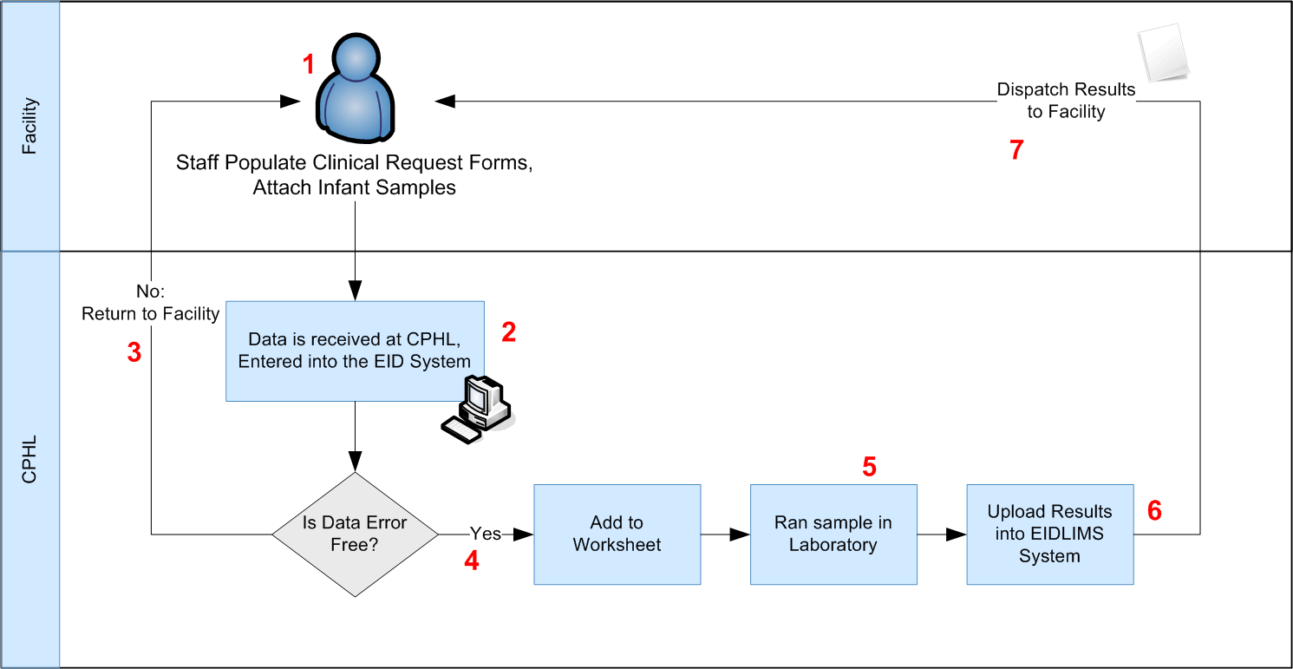

- At the Facility:
Staff fill out the Clinical Request Forms, attach infant samples and send these to CPHL for testing
- At CPHL:
Data from the facilities is received, entered into the EIDLIMS system
- At CPHL:
If the entered data is found to have errors, the data is rejected and the Facility informed accordingly
- At CPHL:
If the entered data is accepted, it's made available for inclusion within a worksheet.
- At CPHL:
Data included within a worksheet may then be ran in the laboratory and once the results are available, they are uploaded into the EIDLIMS system
- At CPHL:
Results are then dispatched to the Facility.
- At the Facility:
Results may be received in physical form (printed documents) or electronically (emailed through the GSM printers).

Current System Shortcomings:
The current system and process flow, suffers the following shortcomings;
- Uniqueness of Infants:
The followup exercise (part of the EIDLIMS) is dependent on a method by which infants can be uniquely identified. Unique identification necessitates that if an infant moves from one Facility to another, they can still be uniquely identified. This is currently only possible from within CPHL by way of "Accession Numbers" (assigned by the current system) but outside of CPHL, there are no unique identifiers for Infants.
Consider the following scenario:
An infant moves from Facility X to Facility Y. When Facility Y remits the infant's information to CPHL, the infant will be assigned a new "Accession Number", in effect regarding this infant as a totally new infant. For this reason, there's no audit trail showing that this infant was previously tested and what the result was.
- Data entry at CPHL:
The current system is designed support entry of several records simultaneously. While this ensures staff can quickly input data, very little validation can be accurately performed on each record.
- Database Design:
  - The current system supports the entry of "Blank" fields in some critical section e.g gender.
  - Indexing of the database tables is poorly done hence the system sometimes suffers from speed related issues
  - Logging of user activities is not undertaken exhaustively hence errors are hard to locate and resolve.

System Redevelopment:
The following steps should be considered for the future system redevelopment (in order of priority);
- At the Facility;
Implement a scheme through which Infants enrolled onto the EID program are uniquely identified. The Infant Caregivers should then be tasked with always presenting the unique identifier assigned to the infant at any facility for tracking purposes. This exercise may necessitate modification of the incumbent Clinical Request Forms.
- At the Facility;
Staff should be trained on the key mandatory fields during data collection to mitigate against the issue of blank fields submitted to CPHL.
- At CPHL:
The new system should be implemented with detailed modifications to the following:
  - Data entry interfaces (one infant entered at a time to provide for accurate authentication of each entry)
  - Comprehensive Data logging/implementation of audit trails to ensure erroneous entries and system bugs are quickly identified and resolved
  - Database Indexing to ensure queries are optimized to ensure optimal system performance
- At CPHL:
Implementation of a revised dashboard with clear statistics
- At CPHL:
Testing of the revised system
- At CPHL:
Cleanup and Migration of the current data from the incumbent to the new system
- At CPHL:
Training of staff on the modifications within the new system. It should be noted that at an interface level, the new and incumbent system may not be significantly different however the underlying architecture for the new system will be significantly improved.

